1).Create a simple cloud software application for Flight Reservation System using any Cloud Service Provider to demonstrate SaaS include the necessary fields such as one way, round trip, From, to, Departure, Departure, Travelers & Class, Fare Type, International and Domestic Flights etc.

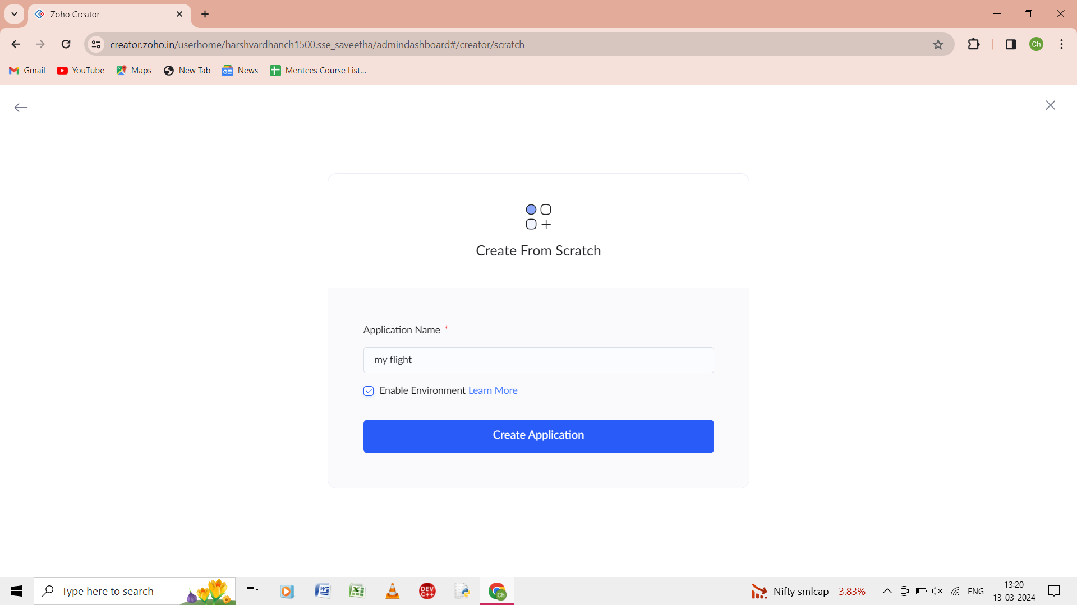

Step1: Give the name of the application as “my flight” and then the application is created.

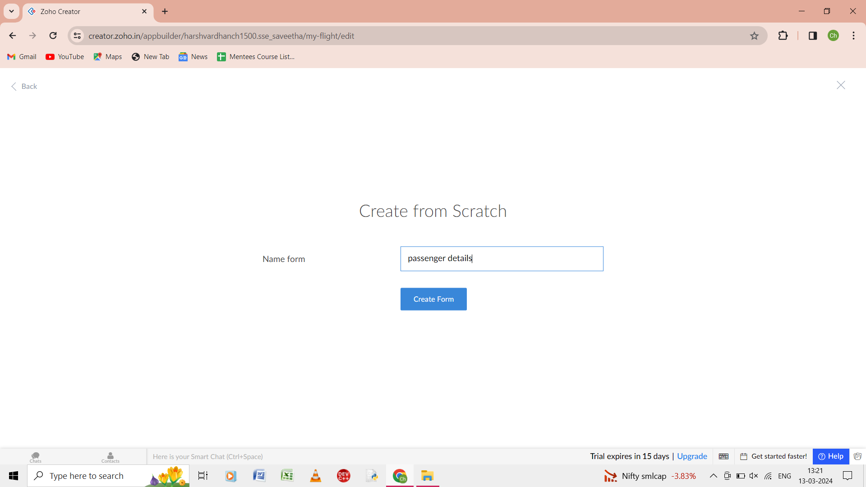

Step 2: from the forms go to the scratch and enter the form as passenger details.

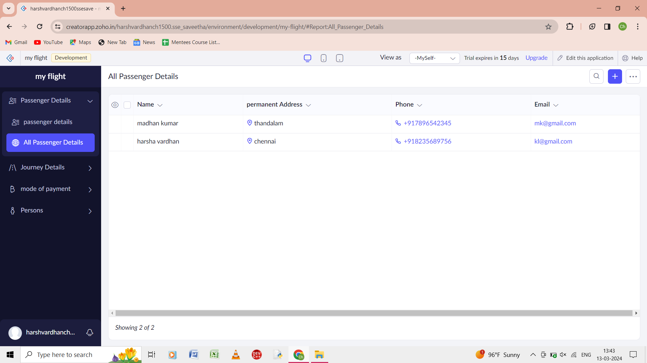

Step 3: output of the form of the passenger details is shown.

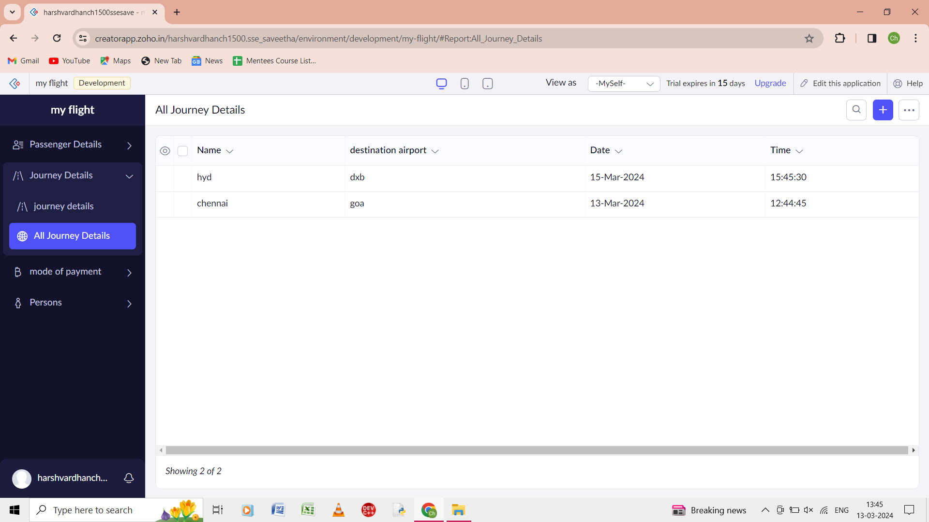

Step 4: And from scratch give the journey details of the form then output of the form of journey details is shown.

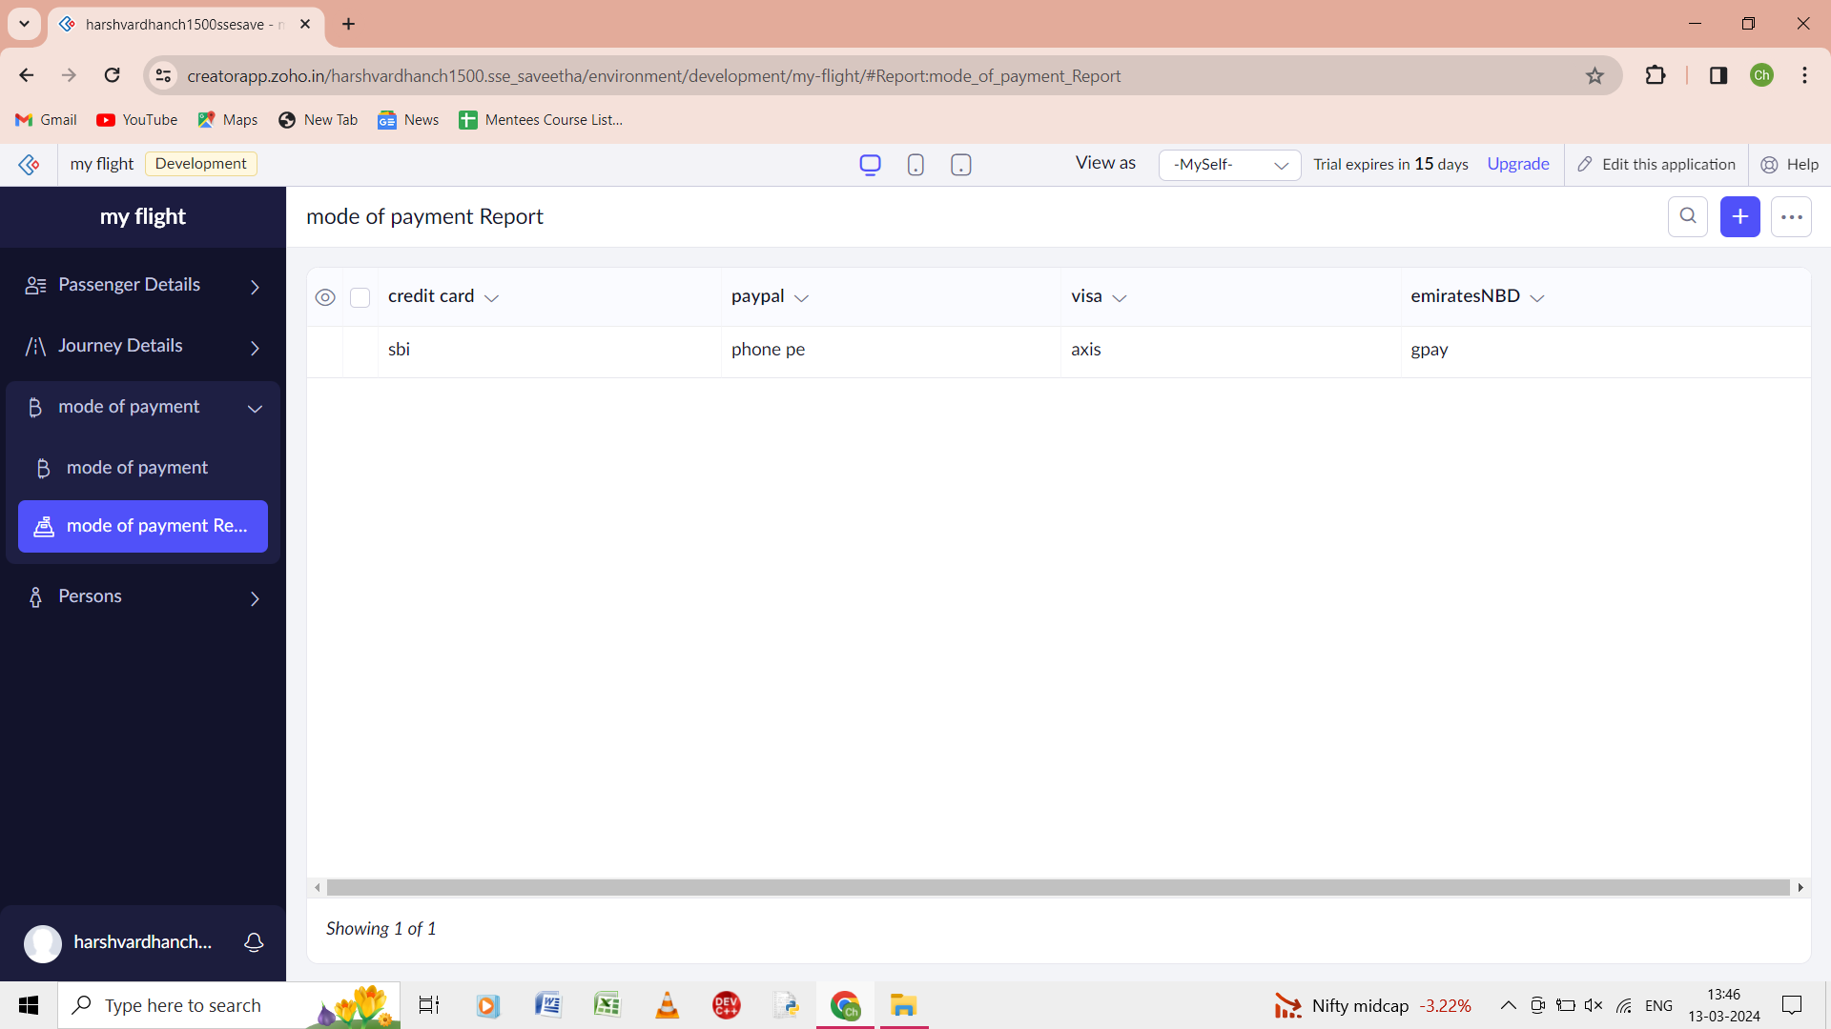

Step 5: And from scratch give the mode of the payment of the form then output of the form of mode of the payment is shown.

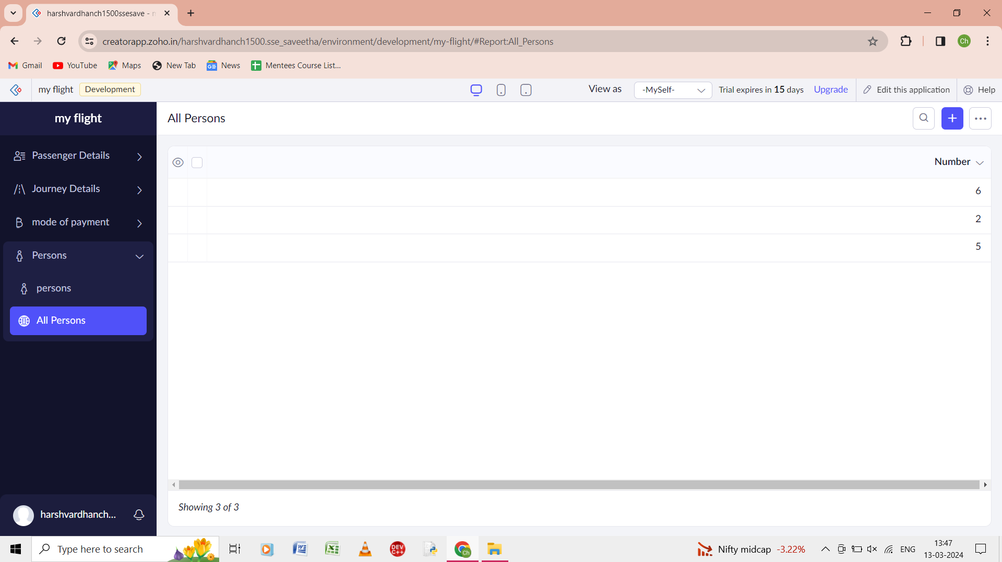

Step 6: And from scratch give the number of persons of the form then output of the form of number of persons is shown.